What have I read that has had the most impact on my training to become a Maths teacher?

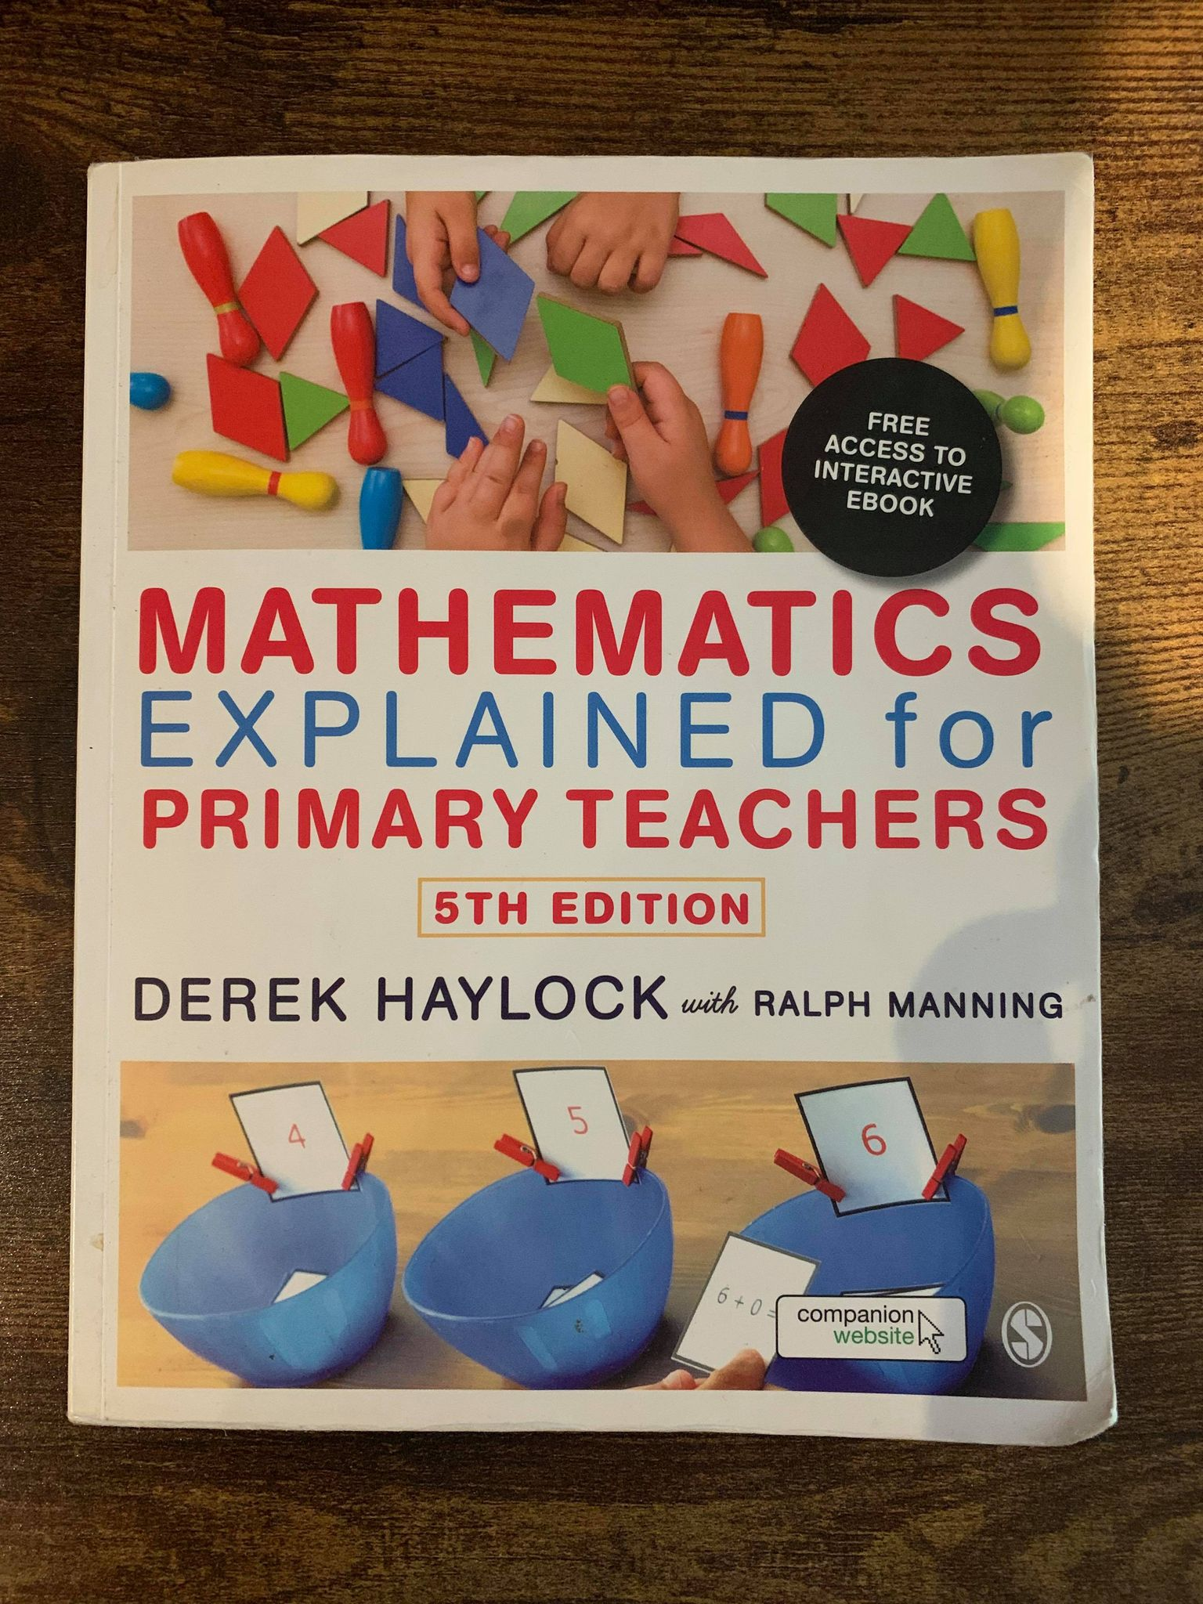

Haylock, D., & Manning, R. (2014) Mathematics Explained for Primary Teachers. London. SAGE.

What is the book about?

The book is about helping teachers and trainee teachers to become secure in both their subject knowledge of Mathematics and their pedagogy.

What are the strengths of the book?

The two authors have both enjoyed successful careers in education and have worked in the Primary sector for many years. The careers of the authors include decades of valuable first-hand experiences which are translated into useful insights throughout the book.

The content is well organised, and the layout of the book is clear and easy to follow. The book includes a contents page and a breakdown of what is covered at the beginning of each chapter.

The book makes good use of images as learning supports and teaching tools. The pictorial representations of Mathematical concepts are sometimes easier to understand than words which makes the content more accessible to the learner.

The book makes links to the National Curriculum (indicated by an icon) and also includes ‘teaching points’ which highlight potential misconceptions and other key information that teachers should consider when transferring the content to the classroom.

There are additional resources included within the book and others that are linked to either the book or the authors. These include:
- Self-Assessment questions for teachers to check their understanding
- A student workbook which works alongside Mathematics Explained for Primary Teachers (Haylock & Manning, 2014).
- 45 check-ups from Numeracy for Teaching (Haylock, 2001) which focus on applying mathematical knowledge and skills to the job of being a teacher

What are the weaknesses?

I think it would be helpful if the activity book was incorporated to the primary text because this would smooth the transition of the content into lesson plan ideas.

The book does not emphasise differentiation which is a key aspect of modern day teaching the Primary classroom. I think it would be helpful if the book included differentiation tips alongside the teaching points.

There are few or no specific links to Mastery in the book which decreases the source’s relevance. Mastery is currently a favoured approach to teaching Mathematics in the United Kingdom after its success in the East has been well documented and recognised by other countries across the globe.

How has the book influenced me?

Firstly, the book has developed my understanding of Mathematical concepts that are included in the Primary NC. I have directly applied this understanding to my teaching which led to improvements to both my pedagogy and the children’s learning of Mathematics.

Secondly, the book highlighted the difference between teaching and learning specific Mathematical concepts in the Primary NC. This is best explained by how I used the book to develop my understanding of Algebra but then was directed by the authors to teach Algebra in an entirely different way. This experience with the book took place during my second-year placement and caused a paradigm shift which affected my entire perception of how to teach the various strands of Primary Mathematics.

Finally, the book educated me on how to avoid misconceptions and recognise that it takes time for certain concepts to be fully understood. This development led to important implications for my entire planning process which now allocates time for understanding to be built gradually with the use of important resources and learning supports.

The book has maintained its relevance and value as a learning resource which I continue to make good use of during my lesson planning.

Closing points for future readers

To get the most out of this book I encourage future trainees to first, pay close attention to the teaching points. The teaching points highlight regular misconceptions and listening to them means that the reader will have more chance to create successful lessons where the children are learning what you want them to learn!

Second, I recommend that trainees write a draft of their lesson plan whilst reading the content in the book. There is a lot of information contained within the book which means that trainees have to identify what is most relevant to their upcoming lessons and I found drafting notes to be effective during this process.

